
Software Requirements
iBEX

4/26/2015
Durmaz Tek.
Istanbul-Turkey

iBEX

Software Requirements Specification

Version 2.0

April. 26.2015

Altay Brusan
Durmaz Teknoloji

Revision History

Date | Description | Author | Comments
04/04/2013 | Version 1.0 | Altay Brusan | Use-case specification of Access Artifact
03/04/2013 | Version 1.0 | Altay Brusan | Use-case specification of snap
25/01/2015 | Version 2.0 | Altay Brusan | Comprehensive requirement analysis
25/01/2015 | Version 2.0 | Altay Brusan | Comprehensive update
23/05/2015 | Version 2.0 | Alper Yaman Altay Brusan | Corrections based on Alper Yaman comments

Document Approval

The following Software Requirements Specification has been accepted and approved by the following:
Signature | Printed Name | Title | Date
 | Altay Brusan | Durmaz Teknoloji
 | Altay Brusan, Alper Yaman | Durmaz Teknoloji

Table of Contents

1 Introduction 6
1.1 Purpose 6
1.2 Scope 6
1.3 Definitions, Acronyms, and Abbreviations 6
1.4 References 7
1.5 Overview 7
2 General Description 8
2.1 Product Perspective 8
2.2 Product Functions 9
2.3 User Characteristics 10
2.4 General Constraints 10
2.5 Assumptions and Dependencies 10
3 Specific Requirements 12
3.1 External Interface Requirements 12
3.1.1 User Interfaces 12
3.1.2 Hardware Interfaces 14
3.1.3 Software Interfaces 14
3.1.4 Communications Interfaces 15
3.2 Functional Requirements 15
3.2.1 FR1 15
3.2.2 FR2 16
3.2.3 FR3 17
3.2.4 FR4 18
3.2.5 FR5 18
3.2.6 FR6 19
3.2.7 FR7 20
3.2.8 FR8 21
3.2.9 FR9 21
3.2.10 FR10 23
3.2.11 FR11 23
3.2.12 FR12 24
3.2.13 FR13 24
3.2.14 FR14 24
3.2.15 FR15 25
3.2.16 FR16 26
3.2.17 FR17 27
3.2.18 FR18 28
3.2.19 FR19 28
3.2.20 FR20 29
3.2.21 FR21 30
3.2.22 FR22 30
3.2.23 FR23 31
3.2.24 FR24 31
3.2.25 FR25 32
3.2.26 FR26 32
3.2.27 FR27 33
3.2.28 FR28 34
3.2.29 FR29 35
3.2.30 FR30 36
3.2.31 FR31 37
3.2.32 FR30 37
3.2.33 FR31 38
3.2.34 FR34 39
3.2.35 FR35 39
3.2.36 FR36 40
3.2.37 FR37 41
3.2.38 FR38 42
3.3 Use Cases 43
3.3.1 System use cases and access level 43
3.3.2 Back up use case diagram 44
3.3.3 Calibrate use case diagram 45
3.3.4 Check use case diagram 46
3.3.5 Configure use case diagram 47
3.3.6 Log use case diagram 48
3.3.7 Account manager use case 49
3.3.8 Monitoring unit use case diagram 50
3.3.9 Print use case 51
3.3.10 Project manager 52
3.4 Objects 53
3.5 Non-Functional Requirements 53
3.5.1 Performance 53
3.5.2 Reliability 53
3.5.3 Availability 53
3.5.4 Security 53
3.5.5 Maintainability 54
3.5.6 Portability 54
3.6 Inverse Requirements 54
3.7 Design Constraints 54
3.8 Logical Database Requirements 54
3.9 Other Requirements 54

Introduction
This document is an official artifact of the requirement analysis phase of the iBEX software platform second edition. Due to major changes in system and annexation of the syncBox to the system this document is more comprehensive with regards to the previous versions.

Purpose
The aims of this document is to clarify the understanding of the developers and the users from the iBEX scope and to draw the system boundaries and requirements.

Scope
The scope of this document is iBEX and it is interface to syncBox. The terms system, iBEX and syncBox are defined in the glossary document. The final aim of the iBEX is defined in vision document.

Definitions, Acronyms, and Abbreviations

TERM | Definition
NDT | Non-Destructive Test
NDE | Non-Destructive Evaluation
SENSOR | Device which measures a physical aspect of an object or phenomenon and returns back an electrical quantity.
X-RAY TUBE | A device which produces photons at x-ray spectrum
FLAT PANEL | A device which produces digital x-ray images.
DETECTOR | In this document, it is same as flat panel.
WORKSTATION | A device on which the iBEX is running for example a tablet, PC or smart phone
OBJECT (TARGET) | The object which is going to be tested.
SYNCBOX | This device is developed at Durmaz Tek. It is responsible for synchronization and controlling the peripheral devices for x-ray modality.
POWER SOURCE | Any type of power source (battery, 3 phase power generator, etc.) that brings the necessary power to the x-ray tube.
P.S. | Abbreviated form of Power Source
MACHINERY | Device which is responsible for positioning, e.g. convey belt.
ACTUATOR | A machine which position sensor and/or tube.
COLLIMATOR | A device to shape the x-ray photon spectrum.
AEC | Automatic Exposure Control. A device controls the exposure dose and cuts the power source when enough dose is measured.
DAP METER | Dose Area Product (DAP) meter is a device that measures the product of dose and area.
FRAME | Each individual x-ray snap is a frame.
AI | An abbreviation of Artificial intelligence. It is unit of iBEX which is responsible for making suggestion about under test objects.
SYSTEM | The iBEX in conjunction with syncBox and security dongle
PERIPHERAL DEVICES | Any device that is externally connected to the system
USER | A user is a person how is going to use iBEX. S/he could be technician, customer crews or administer.
UNIT | Each part of the system and peripheral devices is a unit.
MONITORING | A procedure in which user gets information about status and statistics
CALIBRATION | A procedure for correcting and optimizing a unit.
CONFIGURATION | Setting values into units’ settings.
CHECKING | A process for testing and fixing availability and connectivity of units.
DEBUG | A procedure to get information about events’ history.
DICONDE | Digital Imaging and Communication in Nondestructive Evaluation. Industrial revised version of DICOM.
SERIES | Refer to DICONDE standard [2]
STUDY | Refer to DICONDE standard [2]
INSTANCE | Refer to DICONDE standard [2]
IMAGING PROTOCOL | A set of parameters (KVP, mAs, time, etc.) that specifically define an imaging technique.
THE AVERAGE IMAGING TIME | The total time to prepare the object to take image, exposure time and processing the data ( figure 4)
CONFUSION MATRIX | A standard way of representing performance of AI
ROC CURVE | An standard way of representing performance of AI

The iBEX is consistent with DICONDE standard. Some terminologies which are used in the following chapters are borrowed from this standard.

References
[1] iBEX-Requirement analysis version 1.
[2] Standard Practice for Digital Imaging and Communication in Nondestructive Evaluation (DICONDE), Designation: E2339 − 11
[3] The iBEX Glossary document
[4] The iBEX vision document

Overview
In the following all requisites of any type of direct x-ray imaging devices are introduced. Then the iBEX solution to these demands are introduced.

General Description
A brief introduction to the iBEX and syncBox is given, then major requirements are identified.

Product Perspective
Figure 1 shows a complete list of the x-ray imaging components (complete list of peripheral devices are available in glossary and iBEX-syncBox interfaces) and their connections to the system. In this diagram the control lines are shown in black dashed line. Using these lines, syncBox issues the synchronization and control signals to the peripheral devices and receive their responses. The workstation is connected to the syncBox via a control line. By this mean the iBEX, which is executing on the workstation, could negotiate to the syncBox.
There is a separate “data-line”. This line is used for data transfer between detector(s) and workstation. As far as x-ray frames (images) are bulky (e.g. 20MB per image or more is normal) then a separate high speed line is used to send the raw data from detector to the workstation.
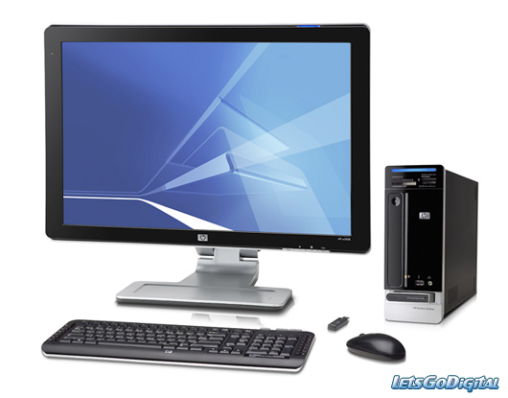
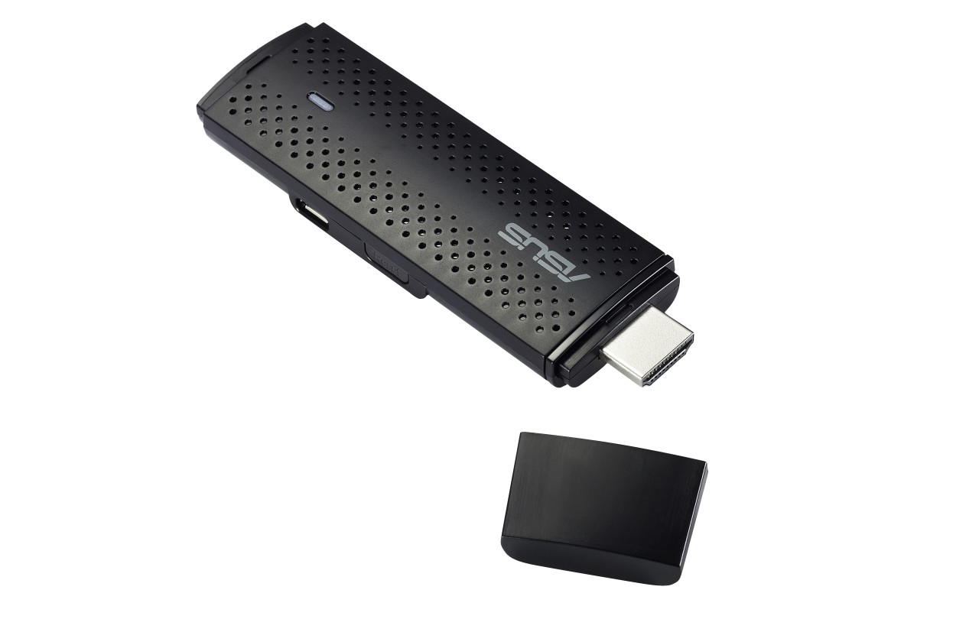
Data Line
Peripheral Devices
Control Line
Work station
syncBox
Detector
machinery
Power source
Collimator
iBEX
Security Dongle
DAP meter
Grid
AEC
Alarm
Cooling & ventilation
Barcode Reader
System
Figure 1 data line vs. control lines

Product Functions
Table 1 lists all major use cases that happen within the system boundary. All of these transactions are initiated by the user. In other words, this table summarize all expectations (i.e. business use cases) from the iBEX from a user perspective.

Table 1 Major functionality requirements from user’s point of view
User transaction |  | Details
Configure a unit | Which includes configuring:
Configure a unit | - iBEX settings  - AI settings  - Network setting  - Image correction |  | - syncBox settings  - Data storage settings  - Alarm settings  - Image processing
Organize project | Orchestrating studies and projects, includes:
Organize project | - Manage projects  - Manage imaging programs  - Review study: view image(s), compare studies, annotate image(s)
Monitor system | A procedure in which the user gets information about status and statistics, includes monitoring:
Monitor system | - x-ray tube temperature  - task statistics  - connections |  | - power source unit  - mechanical unit  - AI performance
Debug system | A procedure in which the user finds the root of a problem within the system, includes:
Debug system | - Manage log: Read Log, Configure log manager  - fetch syncBox stack content
Check unit | A procedure for testing and fixing availability and connectivity of units, includes checking:
Check unit | - AI unit  - Data storage unit  - Network |  | - Data link connections  - syncBox unit  - Machinery unit
Print information | Which includes printing:
Print information | - Studies.  - Log file(s)  - Graphs(s)
Back up data | Which includes backing up:
Back up data | - data storage  - log files
Security | A procedure to trace the user’s transactions, includes
Security | - Manage user accounts  - Controlling access levels  - Sign in/out system
Calibrate peripherals | A procedure for correcting and optimizing a unit
Calibrate peripherals | - Power source  - Detector  - Machinery  - Collimator  - cooling and ventilation |  | - grid  - DAP-meter  - AEC

Beside these, iBEX system provides some intrinsic functionalities that are not separable or disabled. Better to say, these functionalities are needed despite the fact user is not the initiator of them.

Table 2 Major functionality from system point of view
System transaction | Aim
Check dongle | Validate the dongle
Log events | Save events, error status of the system in all steps
Connect to data storage | Connect to DICONDE server and interact with it.

User Characteristics
In this system users belong into one of the two categories: Admin & Operator. For more details refer to glossary document.

General Constraints
- The dongle should be purchased from a trustful provider. Without the dongle, iBEX is not able to boot up. So, a well-known provider with high quality product should be considered.
- A USB port is used for connecting the workstation to the syncBox. So, at least one open USB port is needed on the PC. In addition, the USB driver of the syncBox should be available on the workstation.
- Figure 1 shows a schematic picture of the system. In reality this scene is not as neat as it is shown. For example, AEC may be directly connected to the power source or the detector may need to negotiate with generator. Due to this priori unknown structure and connections, the system should be flexible for any change in connections and device.
- Keeping in mind, the syncBox is required to handle the low level problems such as harmonizing connection and communication issues, while the iBEX is as far away as possible from that type of issues and is responsible for high level requirements.

Assumptions and Dependencies
- The iBEX works on Microsoft Windows (7 or higher) and based on .NET (version 4 or higher) platform.
- The iBEX does not boot if the dongle check is failed.
- The iBEX does not boot if syncBox does not available.
- The iBEX does not manage the workstation’s power. So UPS management of the workstation is out of the iBEX boundaries.
- Data line directly connects the detector to the workstation. In some cases special data transfer cards are needed (e.g. CAM cards, GigE, HDMI etc.). In such situations, the iBEX is needed to have access to the card’s driver and it is in charge of data acquisition.
- Despite the fact that the syncBox is responsible for synchronization and controlling, in some detector models the device may need to receive some controlling signals via data line. The iBEX should handle these scenarios and syncBox is not responsible for these cases.

Specific Requirements

This section studies the functional requirements of the previous section in more detail. The content of this section could be used as a guidance for software design, implementation, and testing phases. But, this is not the software design document nor it does not include over-constraint (or design specification) the iBEX.

External Interface Requirements
As visual elements makes the system more comprehensible for the reader, at the first, visual interfaces (i.e. GUI) are discussed. Then the required functionalities are discussed in more detail.

User Interfaces
After the program is successfully loaded, login page is appeared (figure 2). In this step, user enters the information and if it matches, then the program continue to the main window (fig. 3).

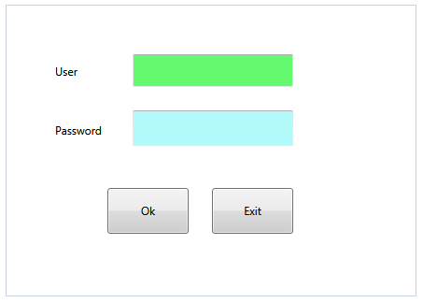
Figure 2. Log in window

If the entered information do not match, then the user can re-try or can get out by pressing ‘Exit’ button.
Figure 3 shows a schematic picture of the main window of the iBEX. User requirements (i.e. Table 1) are categorized in four menus: File, Tools, Setting and Help. In the following these menus are discussed. We have to emphasize that these menus are not concrete. The iBEX makes them whenever it starts loading. So, they are flexible to change. The goal here, is to make the stuffs more clear.

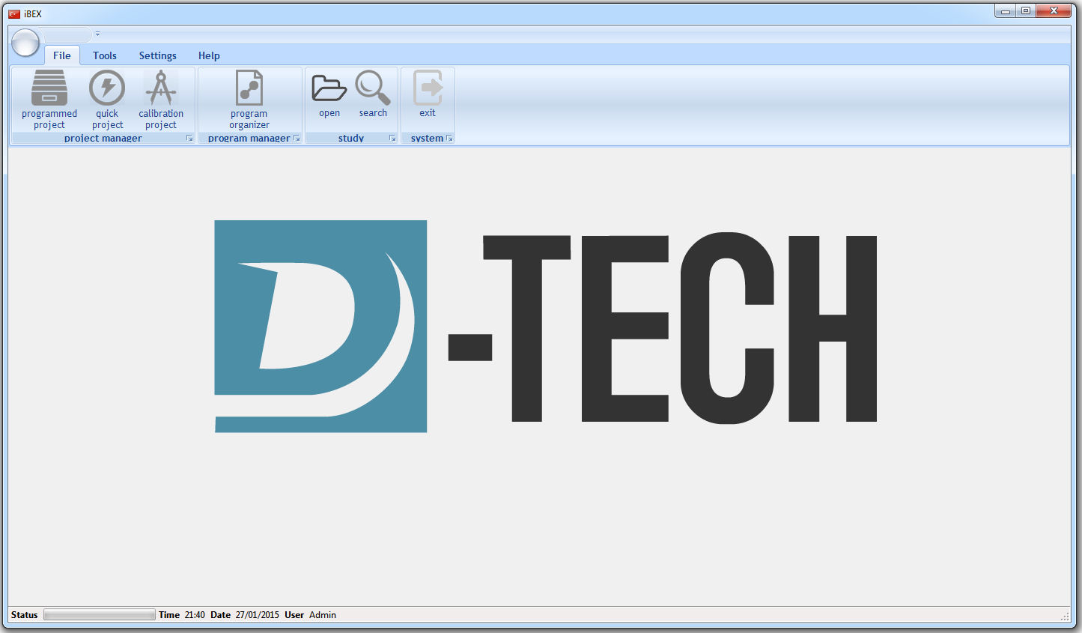
Figure 3. main menu

File: The project manager panel is for starting a study. Program manager lets the operator to define and/or edit “imaging programs”. Study panel provides opening an existing study or search for one within the data storage. Finally there is exist button to quit the iBEX (Figure 7).

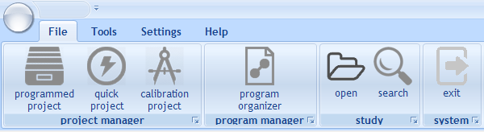
Figure 4. File operations

Tools: Each tool is gadget that let the operator to: control, monitor, view or test an aspect of the system. Figure 5 shows tools menubar. Based on the customization that is applied on the iBEX, the content of this menu bar could be changed.

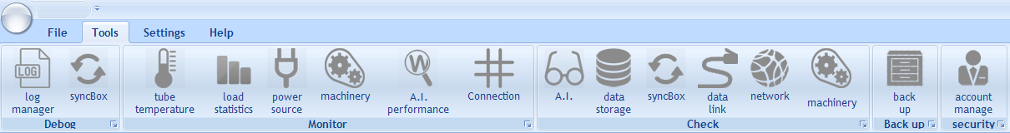

Figure 5 iBEX Tools menu

Settings: in this section user can configure and calibrate peripheral devices. Like “Tools” menu, the component based architecture of the iBEX lets some specific component loads at run time and in consequence this menu is changeable at run time.

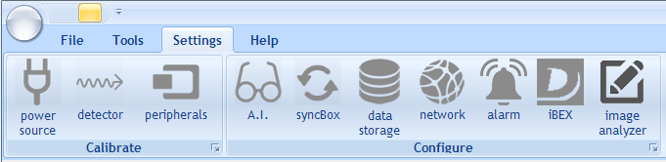
Figure 6 iBEX Settings menu

Help: User guide, dongle validation and contact information are acessable from his tab (Figure 7).

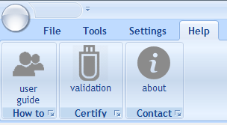
Figure 7 iBEX Help menu

Hardware Interfaces
The iBEX does not load if security dongle or syncBox checking is failed.

Software Interfaces
The iBEX is in need of the following list of external packages and softwares:
- SQL server CE
- DICOM writer
- Peripheral device drivers
- Graphic render
- User interface elements

Communications Interfaces
Communication media between syncBox and iBEX is via USB. However, the connection between the iBEX and detector (i.e. Data Link) may be determined by detector type. At the moment: Wi-Fi, USB3, GigE, HDMI, CAM card are most applied ones.

Functional Requirements
This section describes functionalities of the system. These functionalities may be imitated by a user or the iBEX itself. These functionalities are aimed to satisfy the user transactions (Table 1) and system transactions (Table 2).
This section describes specific features of the software project. If desired, some requirements may be specified in the use-case format and listed in the Use Cases Section.
Debug system

FR1

Use Case Name | Read log file
Introduction | Figure 8 shows all events and their sources happen in the system. A detailed discussion on them are presented in system architecture documents.  Inside the system, all of these events are recorded in two log file: SYSTEMLOG and DEVICELOG. In the case of abnormality, admin select and reads a log file but cannot make any change on the file content.  The system provides a way for admin to read the log contents and select the log file destination.
Trigger | The admin presses the Tools>Debug>log manager button and then select the file to read log file.
Inputs | A log file on which the system history is recorded.
Processing | - Admin select the log file.  - The system checks the system variables for the file location.  - The system loads the file and interpret it.  - The log file is represented.
Outputs | The log file content is shown on the screen.
Post condition | Log files are shown on the screen but the file stream is closed.  No other operation could be executed concurrent with this.
Error Handling | Externally file manipulation (edited, deleted, file name change).  No space to write the log file content.  The log file error cannot stop system from working.
Other | Logs are kept in specific format  SESSION DATA SECTION  <USER> USER-NAME </USER>  <SESSION> DATE-TIME </ SESSION >  ACTION LIST SECTION  <EVENT>…</EVENT>  < WARNING >…</WARNING>  < EVENT >…</EVENT>  < ERROR >…</ERROR>

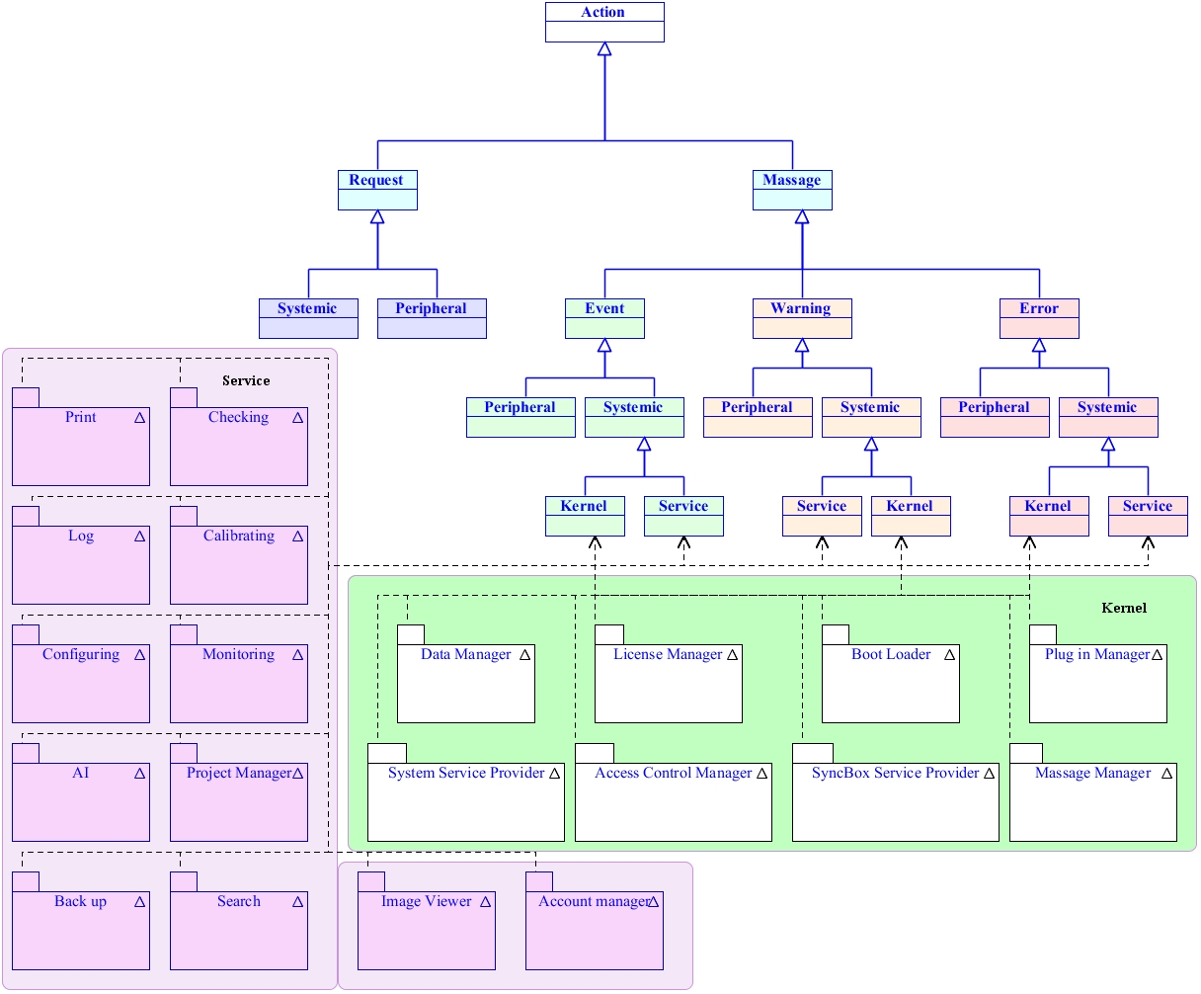
Figure 8

FR2

Use Case Name | Manage the logger
Introduction | When the system is set up for the first time, default values for log file’s location are selected. The admin can change this location to somewhere else on the workstation. This is useful when the log file size is increased and searching inside the file reduces the system response time or there is not enough space on hard drive and logs are needed to be saved somewhere else. Under any circumstance, the logging facility of the system is possible to turn down.
Trigger | The admin presses the Tools>Debug>Manage log button.
Inputs | Destination folder for recording log files.
Processing | Log manager window appears. For each log file a destination is possible to be selected. If this location is same as the previous one, a warning appears which says “The previous log file content maybe deleted or its content will not be over written and cannot be accessible, are you sure? If the user approves, then the file is overwrites the existing file.
Outputs | Save the log file location into system variables.
Post condition | Logger configuration is updated.  When the log file location is changed the old file is completely dismissed. It will not be deleted but it is not used by the iBEX anymore.  No other operation could be executed concurrent with this.
Error Handling | If any file error happens then the user is informed by “No history would be kept” but system still continuous with its normal operation.
Other | Refer to FR1

FR3

Use Case Name | Debug syncBox
Introduction | The iBEX needs syncBox to work. It sends a task stack to syncBox, there the syncBox starts to execute the tasks one by one. For more information refer to iBEX syncBox interface document.  In the case of error within syncBox, admin logs into iBEX and asks for task stack content within syncBox to see the stem of the problem.
Trigger | Critical error in syncBox happened and the admin wants to check it. Tools>Debug>syncBox is pressed
Inputs | Stack content inside syncBox.
Processing | The iBEX sends a request to the task stack content from syncBox.  The syncBox return back the stack content.
Outputs | The content of task stack within the syncBox are fetched and showed. By this information the admin can find out the problem and figure out a way to avoid it. The admin cannot make any change to the stack or reload it back to the syncBox.
Post condition | The syncBox is still in halt state and needs to be reset/refreshed.  No other operation could be executed concurrent with this.
Error Handling | This tool is available to just admin users so the normal operator has no access to it.
Other | Nothing.
Monitor

FR4

Use Case Name | Monitor temperature
Introduction | The temperature is important in system performance, especially the quality of produced x-ray directly depends on the tube temperature.  The user checks out the system temperature once in a while to check if there any problem in cooling system or not.
Trigger | The user presses the Tools>Monitor>Temperature button.
Inputs | The most updated temperature and the temperature history.
Processing | Via syncBox the most updated temperature status is asked from peripheral devices.  The history of the temperature’s status are called from the log file and then shown on GUI.
Outputs | Nothing.
Post condition | User can print the diagrams.  No other operation could be executed concurrent with this.
Error Handling | If there were any problem in connecting, reading or processing (like big ending or small ending) then an error message appears and clarify the situation. Log file errors are also possible.
Other | Nothing

FR5

Use Case Name | Monitor load statistics
Introduction | User needs some statistics from different aspects of studies that already accomplished. For example the operator may want to know :  - How many images of specific object type in a specific period of time are taken?  - How many specimens is tested in a specific period?  - [How many meters of pipe is scanned?]  - What is the average energy per image/specimen?  - What is the average assessment time per image/specimen?  - How many images are taken from each object type?  - What is the system usage time in average?  - What are the acceptance and rejection ratios of each object type for specific period of time?  - What is the dosage per specific period of time?  - What is the average dosage per object?  - What programs are used more?  - How does programs effect on AI suggestions on specific object type?
Trigger | The user presses the Tools>Monitor>Load statistics button.
Inputs | Responses to queries from data storage.
Processing | Get records from data storage  Calculate the user-requested-statistics.  Represent the results.  No data is saved on the original source.
Outputs | Load statistics is presented on the UI.
Post condition | If user demands, statistics are printed.  No other operation could be executed concurrent with this.
Error Handling | Making connection to data storage is a potential to face error. Data processing should be done in reliable way.  In any case, any error is saved into a log file and a message is shown on the screen over load.
Other | Refer to print

FR6

Use Case Name | Monitor power source
Introduction | The power source is the Achilles heel of an x-ray imaging device. Battery, three phase generator, single phase (old machines) and inverter based generators are mainly used in current devices. The details of the device depend on the model and manufacturer. So, it is not easy to enlist what information a user could get from power source. The following list is a good candidate:  - The power source name  - The power source serial number  - The power source status  - The power source connection type (for example RS232)  - The power source error status (directly ask from generator)  - The power source error history (comes from log file)  - If the power source is battery: the power remained
Trigger | The user presses the Tools>Monitor>Power Source button.
Inputs | Status information from generator itself, system-variables and history of the power source from log file.
Processing | Connect to syncBox and ask for PS-status  Get PS configuration from system variables.  Get power source history from log file.
Outputs | PS status is presented on the UI.
Post condition | No other operation could be executed concurrent with this.
Error Handling | potential errors are:  connecting to syncBox  Power low,  Power source does not response or bad shaped data  In all case, any error is saved into a log file and a message is shown on the screen.
Other | Calibrate power source

FR7

Use Case Name | Monitor machinery
Introduction | If iBEX were considered as the top boundary of the system and the syncBox in the middle then the machineries and actuators are the lowest boundary of the system. They are divided into two categories:  Mounted: The machines and actuators are installed over some other existing electro-mechanical components like convey belt. In this case the system may has no control/connections to the existing components.  For example, consider a factory with a convey belt in production line which is controlled by a Siemens PLC. So, making any connection to the Siemens PLC requires special agreement with Siemens at first. If it is not possible to have such contract, then there will be no integration between convey belt and the system.  Designed: despite the previous case, the machines and actuators are designed from sketch and installed in site. In this case, the system is fully integrate-able into the machinery.
Trigger | The user presses the Tools>Monitor>Machinery button.
Inputs | Most-update-status information from mechanics and previous status from log file.
Processing | Making connection to the machinery unit and asking for the status.  Actions that are related to the machinery are excerpted from the log file.
Outputs | Representation on GUI.
Post condition | No other operation could be executed concurrent with this.
Error Handling | Potential errors are:  Making connection to mechanisms  Power low,  Mechanism does not response  In any case, an error is saved into a log file and a message is shown on the screen.
Other | Check machinery

FR8

Use Case Name | Monitor AI performance
Introduction | A.I. unit takes the instances of a series in a study, analyzes them, put some annotation and then suggests “accepted” or “rejected”. This unit also can make a decision for each instance (frame taken from an object) and then based on each decision makes an overall suggestion for the object.  The user can monitor how the performance of this unit was over the previous studies. The user can monitor the performance from different points of views:  - How did the AI perform on a specific object type?  - How did the AI perform on a specific energy range?  - How did the AI perform in specific time interval?  - How did the AI perform based on applied program?  - How did AI perform based on number of images used per object?
Trigger | The user presses the Tools>Monitor>AI performance button.
Inputs | AI decisions which already saved in data storage.
Processing | Information are loaded from database and processed. The results are shown in:  - Confusion matrix  - ROC curve
Outputs | AI performance graphs
Post condition | If user wants, the graphs are printed.  Monitoring AI performance has nothing to do with its activation enable/disable.  No other operation could be executed concurrent with this.
Error Handling | In some cases the AI unit may not work or deactivated on purpose:  - Limited license with no AI.  - Increase the system speed by deactivating the AI by user  - No need to AI  The monitor > AI performance is disabled automatically.
Other | Configure AI

FR9

Use Case Name | Monitor connections
Introduction | The user wants to study the history of each connection and current port map.
Trigger | The user presses the Tools>Monitor>Connection button.
Inputs | The current port map and history of each connection from log
Processing | Get the data from port map and log file  Extract the connections related information  Display the results
Outputs | Connection events
Post condition | No other operation could be executed concurrent with this.
Error Handling | Potential errors are:  Peripherals are disconnected  Port map is out of date
Other | Configure syncBox (port map is configured there).

Checking

FR10

Use Case Name | Checking AI Unit
Introduction | User checks the AI by means of asking the AI unit to perform over a set of off-line studies.
Trigger | The user presses the Tools>Checking>AI button.
Inputs | Studies within data storage or local studies that are not in data storage.
Processing | Load study (local storage, study inside data storage, other units).  Send it to AI  Get results and show.
Outputs | AI suggestion and annotations.
Post condition | No other operation could be executed concurrent with this.
Error Handling | AI is not activated.  Data storage does not response  Images are not valid format.  Too many images are asked from data storage.  In any case, any error is saved into a log file and a message is shown on the screen.
Other | Monitoring AI performance

FR11

Use Case Name | Checking data storage
Introduction | User wants to check if the data storage is available or not.
Trigger | The user presses the Tools>Checking>Database button.
Inputs | Database parameters loaded from system variables.
Processing | Connect to the data storage.  If connection was successful and works fine then a success message is shown on the screen.  Some dummy materials are send to the database and then deleted.  In each step, appropriate message is represented to the user and status is saved into the log file.
Outputs | Data storage operation status is shown.
Post condition | If connection was not successful, the connection is refreshed or the user can restart the data storage server.  No other operation could be executed concurrent with this.
Error Handling | Database connection error for example the database service is turned down or crashed. In this situation, information related to the status is shown to the user and logs are taken.
Other | Configuring data storage.

FR12

Use Case Name | Checking data link
Introduction | The detector sends the acquired frames via separate line to the iBEX. This line is “data link”. User can ask for checking if the link is working or not.
Trigger | The user presses the Tools>Check>datalink button.
Inputs | Nothing
Processing | Connect to data link.  If no problem, then inform user.  If a problem exists, then warn the user and propose solution.  If problem is solved then the process is finished.
Outputs | Save events in log file.
Post condition | If datalink problem is not solved then iBEX turns down.  No other operation could be executed concurrent with this.
Error Handling | Any problem with datalink exists then it is solved by the datalink or detector provider.
Other | Nothing

FR13

Use Case Name | Checking network
Introduction | User checks LAN connection status of workstation.
Trigger | The user presses the Tools>Checking>Network button.
Inputs | IP address and port name.
Processing | The test is based on TCP/IP test routine.
Outputs | Show the connection status on the screen and saved into log file.
Post condition | Nothing
Error Handling | LAN does not exists.  The target does not response.
Other | Configure network

FR14

Use Case Name | Checking syncBox
Introduction | User checks if syncBox is connected to iBEX
Trigger | The user presses the Tools>Checking>syncBox button.
Inputs | syncBox Entry in system variables
Processing | Connect to syncBox  Validate the syncBox  Show the results to the user
Outputs | SyncBox details: manufacturer, version, validation information.
Post condition | No other operation could be executed concurrent with this.
Error Handling | If the syncBox fails then system takes logs and quite.
Other | Configure syncBox.

FR15

Use Case Name | Checking Machinery
Introduction | User connects and sends special commands to machinery unit in order to test if it is working or not.  For example, user may order to rotate detector 20 degrees, lock or release machinery.
Trigger | The user presses the Tools>Checking>machinery button.
Inputs | [If needed machinery entry content in system variables]
Processing | Connect to syncBox  Send the user orders.  Save events into log file.
Outputs | If there is any feedback, it is shown to the user.  Machinery orders are executed.  Log file entries are saved.
Post condition | No other operation could be executed concurrent with this.
Error Handling | If the machinery fails to execute the user commands then it is not the iBEX or syncBox responsibility to solve it.
Other | Configure machinery.

Back up

FR16

Use Case Name | Back up
Introduction | iBEX keeps the data flow in the system in two ways:  - storage server: keep studies  - log file: system history  Admin wants to have a backup from these data sources.
Trigger | The user press’s Tools>Back up button.
Inputs | Studies in data storage or system history in log file.
Processing | Log backup: Admin selects a log file and destination. The log file content is copied to the destination location.  Data storage backup: admin selects a subset (or all) of studies inside data storage and a destination location. The iBEX gets these studies from storage server and then copy them to the destination location.
Outputs | Copy of partial/full contents of storage server.  Log file(s) to a destination.
Post condition | No other operation could be executed concurrent with this.
Error Handling | Data storage fail.  Log file does not available.
Other | Search study and open study, read log.

Security

FR17

Use Case Name | Manage accounts
Introduction | A new account is made or the user password is updated or an existing account is deleted by the admin.
Trigger | The user press’s Tools>account manager button.
Inputs | Account information.
Processing | Admin can create a new “operator account”. In this case the account name and password are needed.  Admin can change the existing accounts password.
Outputs | Updated account information.
Post condition | The system still remains in admin account. If the admin wants to check the created account, first s/he has to sign out and sign in with newly created user account.  No other operation could be executed concurrent with this.
Error Handling | Access level violation,  Account does not exist  User is informed with situation and asked to solve it. A log event is saved.
Other | Sign in

Calibrate

FR18

Use Case Name | Calibrate power source
Introduction | Admin wants to calibrate the power source.
Trigger | The user presses the Tools>Calibrate> power source button.
Inputs | Calibration parameters  [These parameters depends on the power source itself].
Processing | If the power source is calibrate-able, then some type of parameters could be sent to the power source.  However, the better solution is to just show the calibration parameters and encourage the user to calibrate the power source by means of tools that comes with power source.  A log event is taken.
Outputs | Log entries and calibrated power source.
Post condition | Power source is calibrated.  If needed system variables>peripherals>power source are updated.  No other operation could be executed concurrent with this.
Error Handling | Power source calibration is a serious task any error could be non-reversible!
Other | Project manager>calibration project

FR19

Use Case Name | Calibrate detector
Introduction | Detector usually comes with some files that are used during imaging. For example “map file”, “defect”, “dark image” and “white image”. When the admin calibrates the detector, some of these files are updated.
Trigger | The user presses the Settings>Calibrate>Detector button.
Inputs | Files that are provided by the detector manufacturer.
Processing | Admin takes white/black locate the files.  The iBEX load them into system resources folder.
Outputs | Calibration files that are saved in specific location.
Post condition | No other operation could be executed concurrent with this.
Error Handling | File error. It depends on the detector provider.
Other | Project manager>calibration project (FR. start new study)

FR20

Use Case Name | Calibrate peripherals
Introduction | Admin wants to calibrate the AEC, DAP meter, Grid, barcode reader, cooling and ventilation or machinery and actuators.  These operation has two things in common:  - The system has little control over them  - Most of the time there is no standard way to calibrate.  Due to these reasons, the calibration instructions are extracted from user manuals and the menus are updated based on them.
Trigger | The user presses the Settings>Calibrate>Peripherals button and then select the device tab.
Inputs | Calibration parameters and resources.
Processing | The calibration instruction is shown on the screen.  Admin goes through that step by step or selects the calibration resources and the iBEX gets it to the system resources folder.  Appropriate log events are created and saved and if it is required, related system variables are updated.
Outputs | Log events, system variables, system resources and updated peripherals.
Post condition | If calibration imaging is needed, then the user press calibration image button.  No other operation could be executed concurrent with this.
Error Handling | Calibration error: ask for help from technical staffs.
Other | Project manager>calibration project

Configure

FR21

Use Case Name | Configure network
Introduction | Admin configures the LAN settings for both local machine (work station) and storage server.
Trigger | The user presses the Setting>Configure> network button.
Inputs | IP address, port number and Application Entity (AE) of PACS
Processing | First the connection is checked, then the parameters are set to the values given by the user. A copy of network settings are saved into system variable and finally the appropriate log events are saved into a log file.
Outputs | Status are saved into a log file.
Post condition | If the data storage network connection is not possible to make a connection to that then it is automatically ignored.
Error Handling | Network error: in this case system is stopped from working.  Data storage error: in this case system is stopped from working.  If the data storage connection string is changed while there is some data inside the data storage or it is connected then the system warn the user that this action may end up in data lost.  If the workstation machine LAN setting is changed, the user must be warned that the other devices may not be able to connect it any more. So, some data may be lost.
Other | Check network in tools>checking.

FR22

Use Case Name | Configure alarm
Introduction | User is cautioned by three means:  - textual message on syncBox and iBEX,  - sonic  - visual  User configures these alarms’ settings which includes:  - Turn on/off syncBox sound alarm  - Turn on/off visual alarm
Trigger | The user presses the Settings>Configure> Alarm button.
Inputs | sound volume  activation status: enabled/ disabled
Processing | The menu shows up.  User enters the settings values.  The iBEX sends the parameters to the syncBox and also updates the system variable.
Outputs | System variables and syncBox is updated.
Post condition | No other operation could be executed concurrent with this.
Error Handling | unknown
Other | Nothing.

FR23

Use Case Name | Configure syncBox
Introduction | Admin updates port map and trigger modes of syncBox
Trigger | The user presses the Settings>Configure> syncBox button.
Inputs | Port map and trigger modes.
Processing | Port map is shown to admin.  Admin enters the parameters.  Then iBEX sends the configuration parameters to the syncBox and update system variables.
Outputs | Nothing.
Post condition | SyncBox port map is updated. So the device connections are also needed to be updated.  No other operation could be executed concurrent with this.
Error Handling | SyncBox box fails to update  Wrong port map is entered.
Other | Tools>check>syncBox

FR24

Use Case Name | Configure data storage
Introduction | The “data storage” is defined in glossary. The admin can update its parameters such as:  - data storage user name and password  - LAN settings  - image folder  - select save policy
Trigger | The user presses the Settings>Configure>Data storage button.
Inputs | Data storage settings.
Processing | The admin enters the parameters.  The iBEX updates the database parameters in system variables
Outputs | Message on the screen to show that everything accomplished successfully.
Post condition | If it is needed, the iBEX refreshes the data storage connection.  No other operation could be executed concurrent with this.
Error Handling | If any error in updating the data storage happened it should be reported to the user and asked to recheck the parameters.
Other | Check>Data storage, configure>network

FR25

Use Case Name | Configure AI
Introduction | The admin configures the AI unit. This configuration includes  - Selecting options for different subunits  - Turning the AI unit on or off.
Trigger | The admin presses the Settings>Configure> AI button.
Inputs | AI settings.
Processing | Admin enters the AI settings.  the iBEX updates the corresponding system variables
Outputs | AI settings are updated.
Post condition | If it is needed, the iBEX refreshes the AI unit.  No other operation could be executed concurrent with this.
Error Handling | If any error in updating the AI unit happened it should be reported to the user, a log entry is taken and the admin should be asked to recheck the configurations and restart the AI.
Other | Check>AI

FR26

Use Case Name | Configure iBEX
Introduction | The admin configures the iBEX environment settings:  - Language  - Enable/disable showing Time/Date/active user.
Trigger | The admin presses the Settings>Configure> iBEX button.
Inputs | iBEX settings
Processing | Admin enters the parameters.  the iBEX updates the corresponding system variables
Outputs | The iBEX settings are updated.
Post condition | If it is needed, the iBEX refreshes itself.
Error Handling | If any error in updating happened it should be reported to the user, a log entry is taken and the admin should be asked to recheck the settings.
Other | iBEX validation

FR27

Use Case Name | Configure image analyzer
Introduction | After taking a frame, at the first, it gets processed and corrected. For example some detectors provides correction library to crop a specific region on the image.  The image processing is done over the corrected images. For example stitching frames.  The admin configures settings of image processor and correction.
Trigger | The admin presses the Settings>Configure> image analyzer button.
Inputs | Image analyzer settings
Processing | Admin enters the parameters.  the iBEX updates the corresponding system variables
Outputs | The iBEX settings are updated.
Post condition | If it is needed, the iBEX refreshes the image analyzer.
Error Handling | If any error in updating the image analyzer happened it should be reported to the user, a log entry is taken and the admin should be asked to recheck the settings.
Other | iBEX validation

System set up

FR28

Use Case Name | System set up
Introduction | The system is purchased and it is going to be installed for the first time on the site.
Trigger | Set up system in site.
Inputs | Workstation, iBEX, dongle, peripherals and syncBox.
Processing | Cables are connected, port map is adjusted, trigger modes are selected, user accounts are made, network is adjusted, and mechanical components are calibrated. Data storage is installed. After then the iBEX sends Port map, triggers mode and alarm setting to the syncBox. Finally, the setup parameters (e.g. port map) are saved into system variable.
Outputs | System is ready to launch.
Post condition | If setup failed then the retailer should contact to the technical staffs.
Error Handling | Any error in external peripheral devices is informed to customer and the provider of that device.
Other

System evaluation

FR29

Use Case Name | System evaluation
Introduction | The system is already set upped, configured and calibrated. Customer wants to see the operation of the device in place. Also, any possible integration error is needed to be identified. Some evaluation objects (or phantoms) are selected randomly and fed into the system.
Trigger | The user starts new project
Inputs | Complete study information form.
Processing | System works on the evaluation objects.
Outputs | Evaluation performance chart and customers opinion
Post condition | If the final results are satisfactory then the installation is completed.
Error Handling | Any integration error revealed and solved.
Other

Manage studies

FR30

Use Case Name | Start new project
Introduction | The system is already set up successfully and ready-to-use. The user starts a new project. For one of the following two reasons  Starting a new study:  The user wants to assess an object.  Special purpose images:  In some situations user needs to take special images. For example during calibrating detector, the user needs to take some dark image with no exposure or white image under specific exposure parameters.
Trigger | The user presses File>Project manager>quick project or File>Project manager>programmed project button.
Inputs | The new project parameters which includes:  - operator name  - date-time  - program  - end condition
Processing | User selects a program.  [If quick mode is selected the program is created].  Environmental parameters, like user name and date are read from system variables (User cannot change them).  The project starts and continues till end condition reaches.  When a non-special study is accomplished it is automatically saved into the data storage.
Outputs | New study.
Post condition | If an emergency button is pressed or interlock interrupt is activated then the study is suspended.  The iBEX is collaborating and connected to syncBox.
Error Handling | A unit may fail during the process of study. In that case everything should come to halt and a log entry is saved.
Other | Organize program, Open study functional requirement

FR31

Use Case Name | Search study
Introduction | The user needs to search for a specific study. The search could be based on:  - Operator  - Date and/or Time interval  - Object barcode  - Energy level  - Imaging protocol  - Object type
Trigger | The user presses File>study>search button
Inputs | Studies stored in data storage
Processing | The user gives the specification of the study. An appropriate commands are produced and then sent to the data storage. The returned outcomes, first enlisted and presented to the user and then the user double clicks on an entity on the list. The images and other tags then shown to the user.
Outputs | The list of studies.
Post condition | If the selected study did not find then an empty list is shown
Error Handling | User may ask for a wide range of studies. For example the user may ask for whole the information content of the data storage, this could crash the system and should be prevented before ahead.
Other | Open study

FR30
Use Case Name | Organize program
Introduction | User wants to:  - Define new imaging program  - Edit existing imaging program  - Update an imaging program  - Delete an imaging program  - Save an imaging program  - Enlist imaging programs
Trigger | The user clicks on File> Organize program
Inputs | Existing protocols on the system.
Processing | System panel is shown.  The operator can define/edit existing “view”, “technique” or “object type”.  By means of these, user defines a program for imaging.
Outputs | An imaging program.
Post condition | Program, view, technique and object type each has to have a unique name.
Error Handling | Programs are not saved if essential fields are priori-defined.
Other | Start new project

FR31

Use Case Name | Open study
Introduction | User opens an existing study.
Trigger | The user clicks on File> Open
Inputs | A valid DICOM/DICONDE file with .dcm extension or selected item from search list.
Processing | User locate the file [or search for a study and select one]  The iBEX loads it  The content is shown and the user can edit it and save it.
Outputs | A valid DICOM/DICONDE file with .dcm extension  Updated record within data storage
Post condition | If the file location is inside the data storage then the user is warned that s/he has to save file before exiting.
Error Handling | File is not valid: a warning is shown to the user
Other | Search study, start new project

System validation

FR34

Use Case Name | Check dongle
Introduction | In order to have iBEX work correctly a security dongle is needed. This dongle is purchased from a third party. When system is loading, the dongle is checked.
Trigger | System booting up.
Inputs | Dongle security information which is stored in system variables.
Processing | When system is loading iBEX connects to the dongle and check its existence and validate the security code. If this step is approved then system continues with its operation
Outputs | Nothing
Post condition | Depends on validation result, either system boots up or fails and does not boot.
Error Handling | If validation fails then an error message appears and user is asked to check the dongle.
Other | Certify system

FR35

Use Case Name | Certify system
Introduction | After successful loading, user can check system certification.
Trigger | The user clicks on Help> Certify>validation
Inputs | System version and other certification information.
Processing | Dongle information and iBEX entries are loaded from system variables and shown to the user.
Outputs | Dongle related information
Post condition | Nothing.
Error Handling | Any error is logged and system quits.
Other | Dongle check

Help

FR36

Use Case Name | Read user guide
Introduction | User can get assist in two ways:  Read the user guide  Contact technical stuffs.
Trigger | The user clicks on Help>How to>user guide or Help>contact us
Inputs | Nothing
Processing | User manual is installed when the system is set up. The user can open it up and read it or can directly contact a technical staffs.
Outputs | User manual.
Post condition | Nothing.
Error Handling | User manual may be deleted accidentally out of iBEX. In this case an error message appears on the screen.
Other | Nothing.

Print

FR37

Use Case Name | Print
Introduction | The user prints a study (DICOM file) or log file.
Trigger | The user presses a “Print button”.
Inputs | Destination study or selected log file.
Processing | - The user searches for a study.  - User selects one.  - The contents are shown to the user.  - User presses print button.  Or  - User presses print on calibration, monitoring to print performance graph.  Or  - User open a log file  - User press print button.
Outputs | Printed form of a study, log file or a graph.
Post condition | Nothing.
Error Handling | Error mainly is related to printer itself like tuner is empty. All of them are responsibility of printer device itself.
Other | Manage project, monitor load statistics, manage log

Safety

FR38

Use Case Name | Emergency stop
Introduction | In the case of emergency the user presses an emergency stop button. The system stops
Trigger | The user presses “emergency stop button”.
Inputs | Emergency stop signal
Processing | The syncBox gets the signal, halts tasks in the task stack, lock the machinery, send a feedback to iBEX and wait to hear from the iBEX  The iBEX shows an emergency button is pressed button on the screen.
Outputs | Printed form of a study, log file or a graph.
Post condition | If the iBEX was in the middle of a study:  - The last study will be missed  - A warning is informed to the user.  After then, the iBEX clears and reload the syncBox with the last program task stack.  If the iBEX was not in the middle of study then iBEX just clear syncBox task stack.
Error Handling | Nothing.
Other | Manage project, monitor load statistics, manage log

Use Cases
Some major use cases are identified and represented in this section.

System use cases and access level

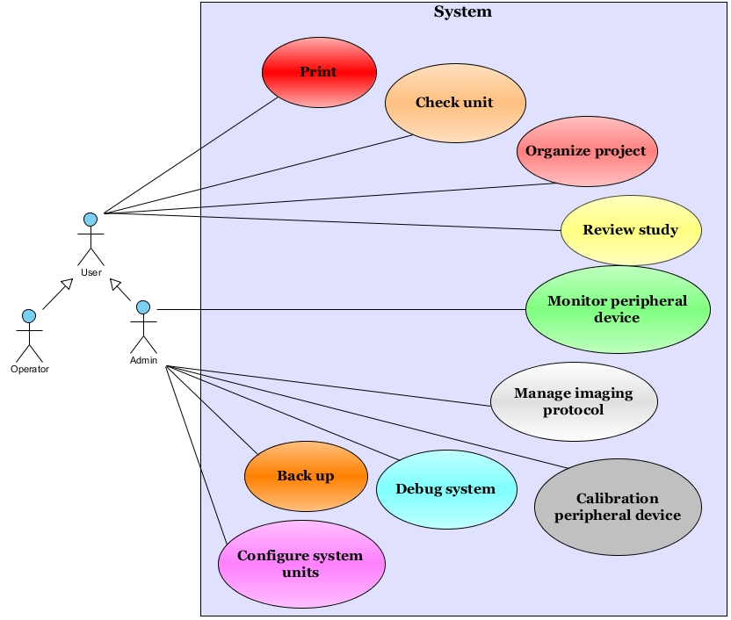

Back up use case diagram

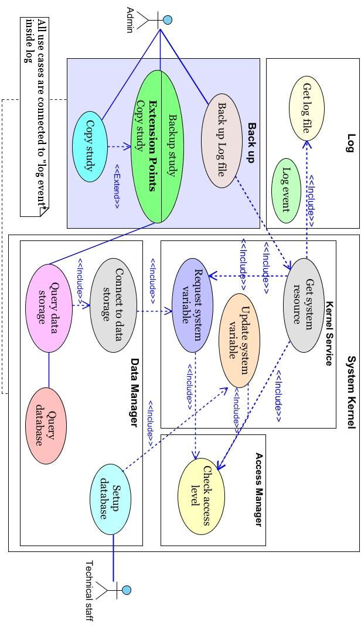

Calibrate use case diagram
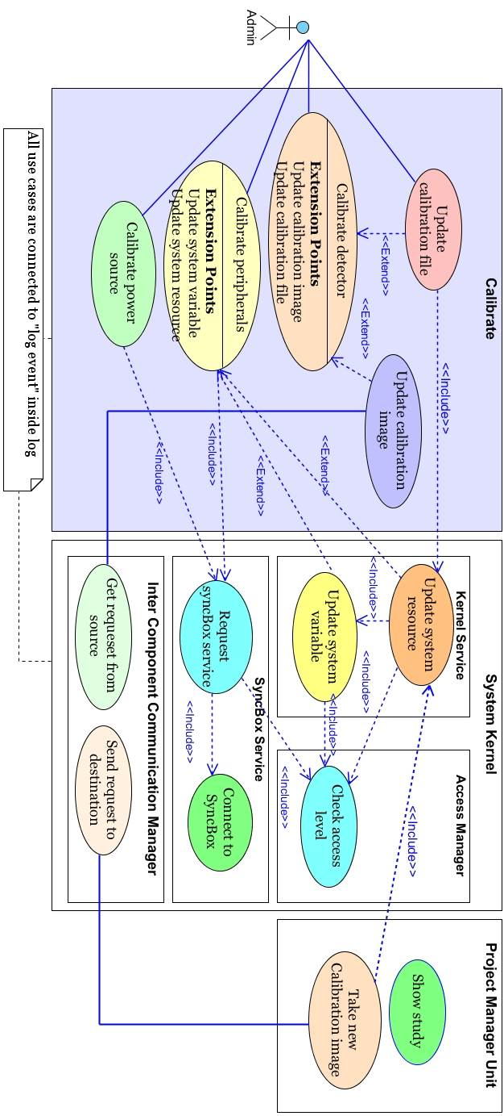

Check use case diagram

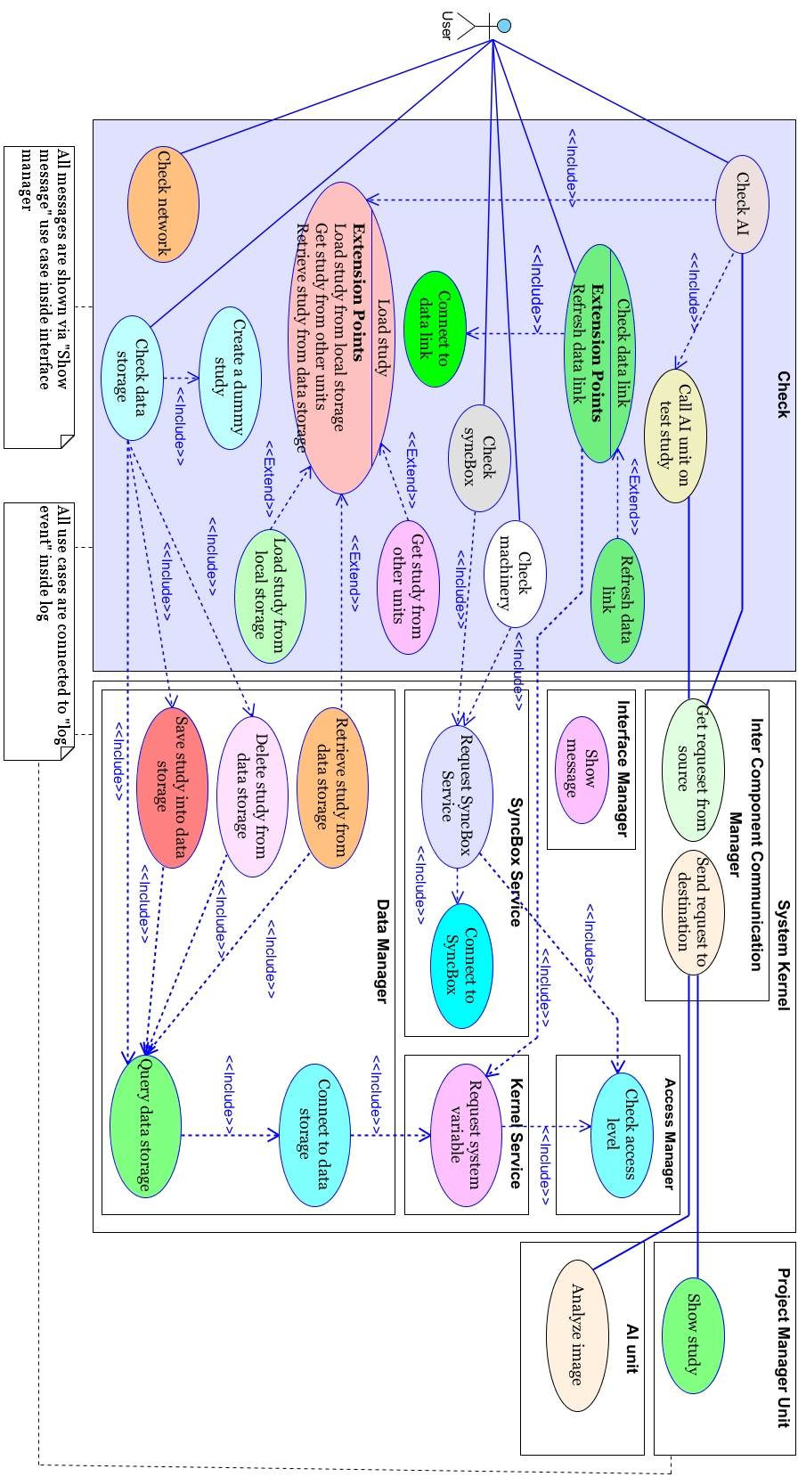

Configure use case diagram
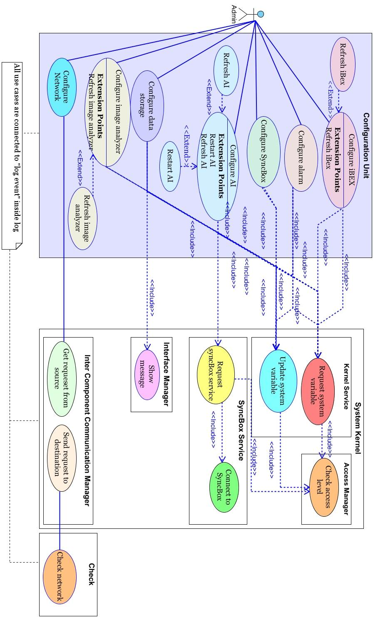

Log use case diagram
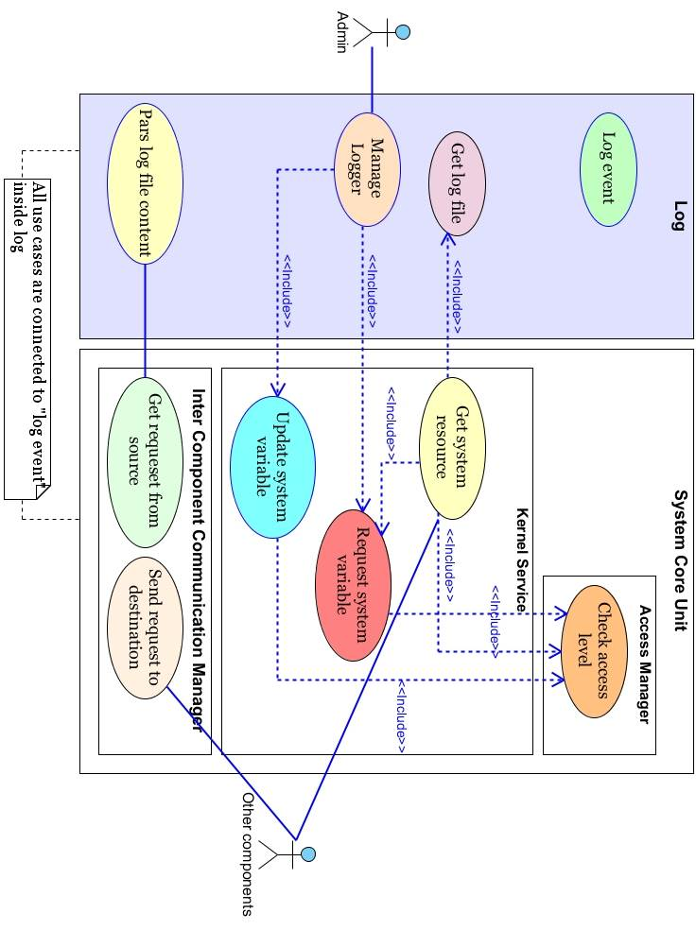

Account manager use case

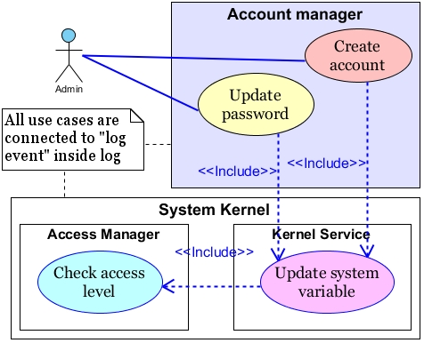

Monitoring unit use case diagram
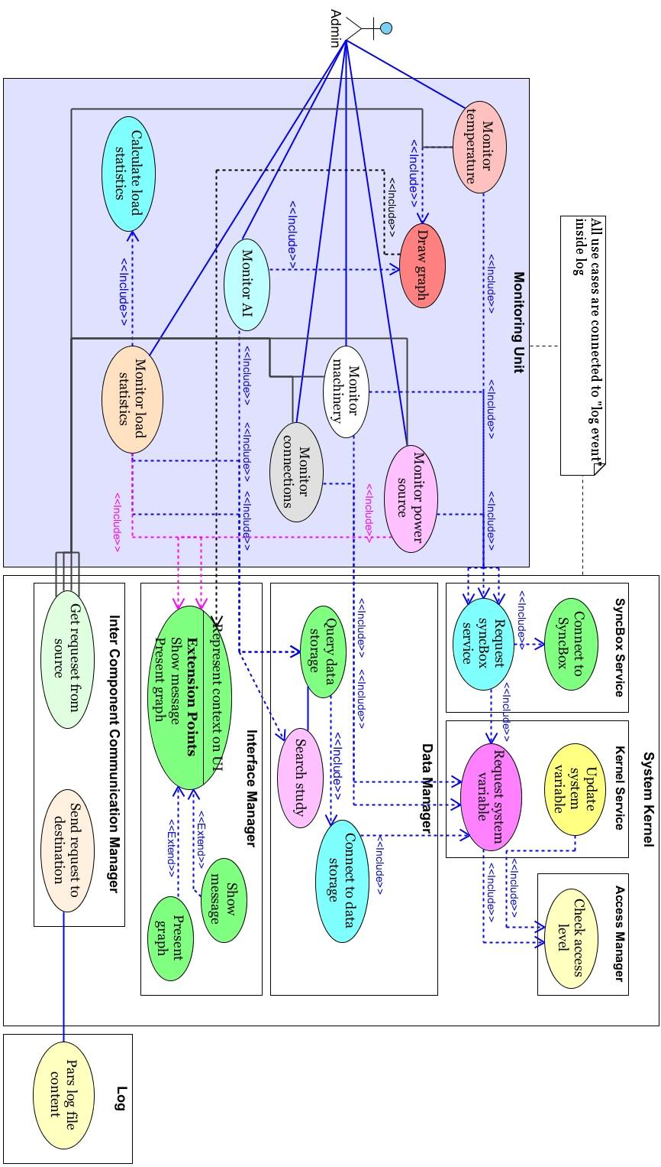

Print use case
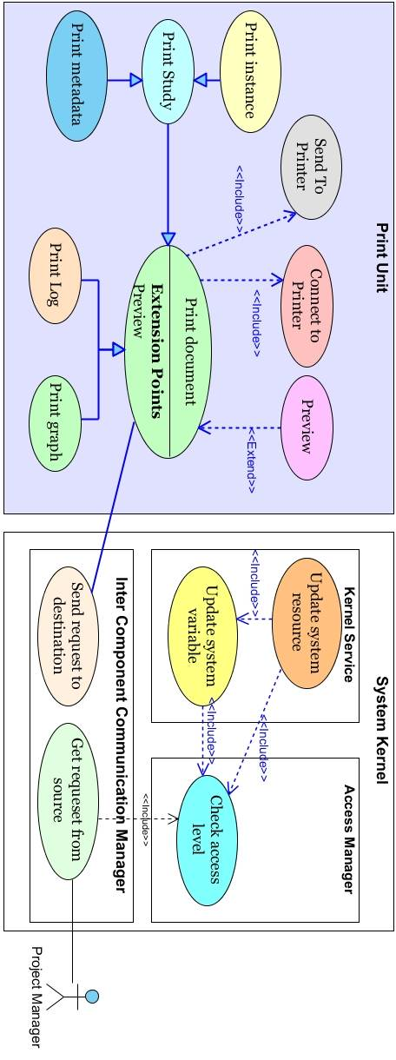

Project manager
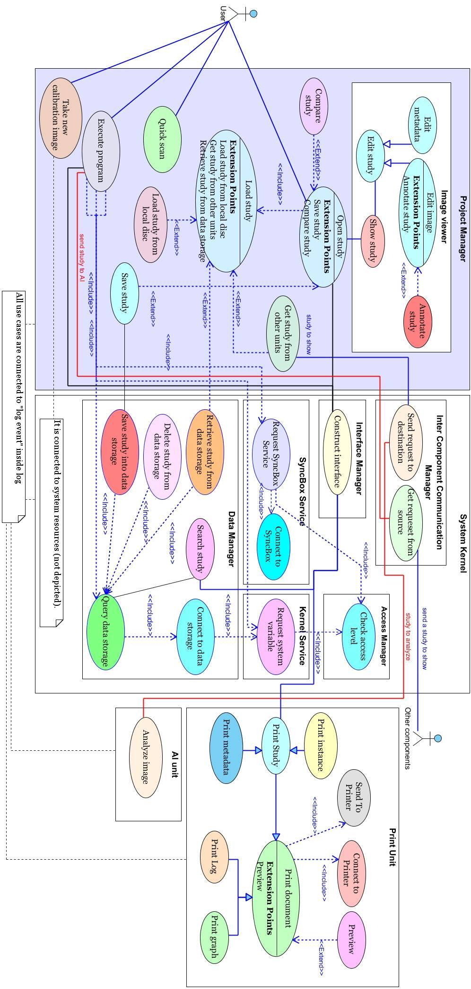

Objects
Configuration parameters are stored within system variables. This parameters are saved under different entry. Following figure shows structure.

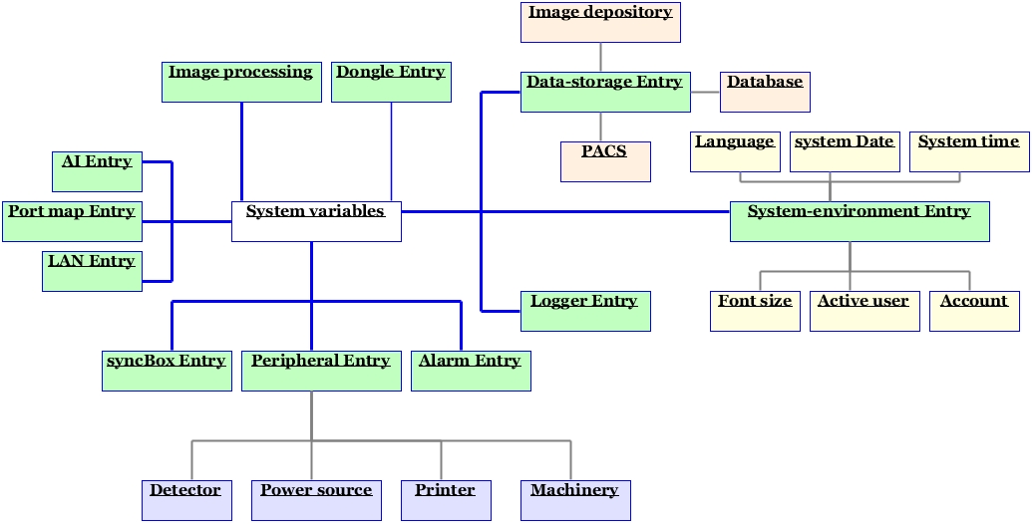
Figure 9

Non-Functional Requirements
Some functional requirements are considered during identification.

Performance
The system is real time. This term is interpreted in context. In some applications 1 sec (or so) average imaging time is considered real time. In the other application it may take a few minutes to process an object images.

Reliability
In the case of emergency a push button is pressed by the user this button stops the system completely.

Availability
The iBEX shall have an availability of 999/1000
The iBEX is possible to be configured such that its throughput under an increased load gets raised up.

Security
All users have to sign when system is started.
All accesses are “checked” inside kernel.

Maintainability
Modular design lets the system to be extended to support other functionalities.
MVVM (Model-View-ViewModel) based architecture in conjunction with WPF (Windows Presentation Foundation) increase the system ability to fix defects

Portability
System is designed under .NET 4.5. It is designed for Microsoft Windows.
It is possible to be shifted to the other platforms.

Inverse Requirements
The program should be written in such a way that no way it is patchable.

Design Constraints
If the iBEX is going to be used on portable device then some modules and unites are not needed to run. Also, if a device is changed then it is just enough to put new .dll files into appropriate folder. The system automatically updates the menus.
The system should use office 2007/2013 style ribbon bars. Also some critical reports should be shown by means of graphical interfaces.

Logical Database Requirements
System uses:
SQL CE

Other Requirements
Color and artistic design should be approved by a professional body.

If any term is ambiguous, please refer to the 1.3 definitions. For more discussion refer to glossary document.
The iBEX may need to work independent of syncBox. So, a separate dongle is provisioned.
This assumption may change in the next versions of syncBox and iBEX.
Refer to glossary, and project manager documents.
In this version the iBEX supports just local data storage (glossary).

